**Dynamics of *Teleaulax* cryptophyte prey during the decline of red water blooms**

**in the Columbia River Estuary**

*Authors:*

Maria Hamilton 1,2, Gwenn M. Hennon 1,3, Joseph Needoba 4, Katie Maxey 4, Rhonda Morales 1, Tawnya D. Peterson 4, Megan Schatz 1, Jarred Swalwell 1, Peter Zuber 4, E. Virginia Armbrust 1, Francois Ribalet 1\*

*Affiliations:*

1 School of Oceanography, University of Washington, Box 357940, Seattle, WA 98195 USA

2 Present address: Ocean Sciences Department, UC Santa Cruz, 1156 High Street, Santa Cruz, CA 95064

3 Lamont-Doherty Earth Observatory, Columbia University, 61 Route 9w, Palisades, NY 10964

4 Institute of Environmental Health, Oregon Health & Science University, 3181 SW Sam Jackson Park Rd., Portland, OR 97239 USA

\* Corresponding author: ribalet@uw.edu

**ABSTRACT**

The mixotrophic *Mesodinium major* is a globally distributed nontoxic ciliate that relies on the acquisition and use of chloroplasts derived from its cryptophyte prey, *Teleaulax amphioxeia.* The ecology and physiology of the *T. amphioxeia* prey is not well known, nor is it clear how their growth influences the initiation, development and decline of *M. major* blooms, which at high abundances, can turn the water red. To better understand how environmental factors influence the population dynamics of *T. amphioxeia*, a 4-week survey was conducted in the Columbia River estuary in 2013 during which abundances and division rates of the cryptophytes were continuously monitored using flow cytometry. The highest abundance of free-living *T. amphioxeia* occurred during the first neap tide with concentrations as high as 1.8 x 106 cells L-1 and decreased during spring tide and later neap tides (< 0.5 x 106 cells L-1). A 10-fold variation in cryptophyte cell abundance occurred daily, which was not associated with the daily tidal cycle or the spring/neap tide cycle. Cryptophyte division rates, predicted *in situ* here for the first time, ranged from 0.2 to 1.5 d-1, with the highest rates observed in accordance with high abundances of *T. amphioxeia.* These division rates were positively correlated with concentrations of dissolved inorganic nitrogen and phosphorus, suggesting nutrient availability, rather than light conditions, limits the growth of cryptophyte cells in the Columbia River estuary. Calculations of *T. amphioxeia* production compared to *M. major* abundances showed that the growth of the ciliate during the survey may have been limited by prey availability.

Key words: cryptophytes; *Teleaulax; Mesodinium;* growth rates; SeaFlow.

**INTRODUCTION**

The common coastal ciliate, *Mesodinium major* was previously included in the *Mesodinium rubrum* (*Myrionecta rubra*) (Lohmann 1908) Jankowski 1976 species complex (Garcia Cuetos et al. 2012) and is among the marine microzooplankton that temporarily maintains the plastids of their cryptophyte algal prey, *Teleaulax amphioxeia* (Herfort et al. 2011). This association allows the ciliate to function as a mixotroph, capable of utilizing both phagotrophy and photosynthesis to acquire carbon (Crawford 1989). Although *M. major* populationsare important primary producers in many coastal and estuarine systems (Stoecker et al. 1989, Herfort et al. 2012), little is known about the ecology and physiology of the *T. amphioxeia* prey and how their growth and abundance may influence bloom dynamics.

Massive *M. major* blooms occur each summer in the Columbia River estuary (CRE) (Herfort et al. 2011). The blooms persist for several weeks during the late summer and early fall, and shift the trophic status of the estuary from net heterotrophic to net autotrophic (Herfort et al. 2012). The annual *M. major* bloom appears to be initiated during summer neap tides (Herfort et al. 2011), when both tidal forcing and the seasonality of freshwater discharge result in an extended summer saltwater intrusion (Chawla et al. 2008). The blooms appear to start in Baker Bay, where a shallow depth and long water-retention time favor the persistence of high cell abundances (>100 cells mL-1) and fast division rates (1.2–3.1 d-1) of *M. major*. Within a few weeks, the initial blooms spread throughout the main estuary (Herfort et al. 2011). A decline in the abundance of small (<5 µm), free-living *Teleaulax* cells coincided with an increase in *M. major* abundance observed in the CRE in 2011 (Peterson et al. 2013), suggesting a direct link between consumption of the cryptophyte prey and the initiation of *M. major* blooms. Further evidence of a connection between prey populations and the development of *Mesodinium* blooms was observed in an Antarctic saline lake, where an increase in the abundance of cryptophytes preceded the increase in abundance of *M. rubrum* (van den Hoff & Bell 2015). However, the factors that influence cryptophyte prey population dynamics remain poorly understood in these systems, and the underlying mechanisms linking ciliate and prey populations are unclear. For example, does the physiological status of free-living cryptophyte prey (as indicated by division rate rather than population size) influence the dynamics of *Mesodinium* blooms?

To investigate the influence of prey population size and physiological status on the dynamics of *Mesodinium* blooms, we examined patterns in abundances and division rates for free-living *T. amphioxeia*. Numerous factors influence cell abundances, including cell division and cell mortality, and physical advective transport. In a dynamic system such as the CRE, only a continuous sampling approach can capture changes in abundances over time. Continuous measurements of the population size structure can be used to estimate division rates based on changes in cell size distribution over the course of a day (Sosik et al. 2003, Hunter-Cevera et al. 2014, Ribalet et al. 2015). This method eliminates many of the difficulties and biases associated with the determination of cell division rates using discrete sampling techniques (Laws 2013).

Here, we use the continuous flow cytometer, SeaFlow (Swalwell et al. 2011) to determine cryptophyte abundances and division rates both in the laboratory and during a 4-week survey carried out in 2013. Dissolved nutrient concentrations, salinity, temperature, light irradiance, and abundances of cryptophytes and *M. major* were determined during red water blooms in the CRE. Daily division rates of cryptophytes were calculated from the change of size distribution over a 24-h period using a size-structured division rate model (Ribalet et al. 2015). The abundance and division rates of cryptophyte populations were compared with abundances of *M. major* to determine the influence of prey physiology and abundance on the dynamics of red water blooms.

**METHODS**

**Study Area**

Samples were collected at 2.4 m depth over the course of 1 month, 4 days a week, from September 11th to October 2nd 2013 from a continuous seawater flow-through system at SATURN-03, a fixed station located at the end of a dock in Hammond, OR (**Fig. S1**) (Baptista et al. 2015). Discrete samples were also collected at the station during the turn of the high tide (i.e., at slack water).

**In situ monitoring**

Water temperature and salinity were measured at SATURN-03 using a SeaBird 37 Conductivity-Temperature (CT) meter deployed in-line with the pumped water system described in Baptista et al (2015) that alternates between 3 depths. For this study, water measurements were extracted for the 2.4-m depth corresponding to the flow cytometery sampling described below. Water temperature, salinity and pH were measured continuously at SATURN-03 using a SeaBird Conductivity-Temperature (CT) meter for temperature and salinity, and a Durafet pH sensor (Honeywell) and a chlorophyll fluorometer (Turner Designs). Photosynthetic Active Radiation (PAR) data were obtained from Desdemona Sands Light mooring, located 3 km north of SATURN-03.

**Inorganic nutrients**

Duplicate nutrient samples were collected from water pumped to the surface at SATURN-03, collected in temporary bottles and then filtered into 30 ml HDPE storage bottles. All bottles for collection and storage of samples, syringes, and filter housings were washed with 10 % hydrochloric acid and rinsed 3 times with deionized water before use. Bottles, syringes, and filter housings were dried, capped, and stored in clean Ziploc bags until use. Collection bottles were rinsed three times with sample and filled by gently pushing sample through a clean Swinnex filter holder and combusted 25-mm glass fiber filter (Whatman GF/F) using a clean 60-ml syringe. Storage bottles were rinsed three times with filtered sample before final filling; samples were frozen upright at −20 °C.

Nutrient concentrations were determined using an Astoria Analyzer (Astoria-Pacific, Clackamas, OR, USA). Before analysis, all samples were thawed in a water bath (55 °C) and cooled to room temperature. Nitrate, nitrite, ammonium, and orthophosphate were determined using manufacturer recommended methodology (Armstrong et al. 1967, EPA 1984, EPA 1997). These methods have minimum detection limits (MDL) of 0.5, 0.2, 0.3, 0.2 μM, respectively. Quality assurance was maintained by running certified reference material (ERA catalog #4023).

**Determination ofcryptophyte cell abundance and cell size**

Continuous measurements of cryptophyte abundances and cell size were made using SeaFlow (Swalwell et al. 2011). The instrument was equipped with a 457-nm 300-mW laser (Melles Griot). Forward light scatter (a proxy for cell size), red, and orange fluorescence were collected using a 457–50 bandpass filter, 692–40 band-pass filter, and 572–27 bandpass filter, respectively. Seawater was prefiltered through a 100-µm stainless steel mesh (to eliminate large particles) prior to analysis. The flow rate of the water stream was set at 15 mL min−1 through a 200-µm nozzle. A programmable syringe pump (Cavro XP3000, Hamilton Company) continuously injected fluorescent microspheres (1 µm, Polysciences) into the water stream as an internal standard. Files were written every three minutes. Data were analyzed using the R package *Popcycle* version 0.2 (available on GitHub). A sequential bivariate manual gating scheme was used to cluster the cryptophyte population based on forward light scatter, orange and red fluorescence measurements.

To confirm the identification of cryptophyte cells, discrete samples for flow cytometry were collected once a day during slack tide, fixed with 0.025% glutaraldehyde and stored at -80 ºC. Six months after sample collection, fixed samples were analyzed with a BD Influx cell sorter equipped with a 488-nm 200-mW laser (Coherent). One hundred cells from the gated population with high orange fluorescence and high red fluorescence (assumed to represent phycoerythrin-containing cryptophytecells) were sorted onto a glass slide. Sorted cells were examined under a Nikon Eclipse 80i epifluorescence microscope at 400x magnification and photographed using a Qimaging MicroPublisher 3.3 RTV camera.

We estimated cryptophyte cell size using an empirical relationship between light scatter measured by SeaFlow and cell size measured by a Coulter Counter for different exponentially growing phytoplankton cultures of cell sizes ranging from 1 to 10 μm (Ribalet et al. 2015).

**Estimates of cryptophyte cell division rates**

*Laboratory culture validation*

A non-axenic culture of the cryptophyte *Rhodomonas* sp. (CCMP 755) was grown in the laboratory in natural seawater amended with f/2 nutrients at 13 °C with a 16:8 light-dark cycle of 100 µE m-2 s-1 provided by white fluorescent tubes. The culture was grown for 4 d in a 20-L batch culture and continuously mixed with a magnetic carboy stir bar. A peristaltic pump (Peri-Star Pro, World Precision Instruments) collected samples at a rate of 15 mL min−1 for 15 min every hour for measurement with SeaFlow. On day 3, 1 mL samples of the culture were collected in triplicate every 2 h for 28 h, fixed with 0.01% glutaraldehyde and stored in liquid nitrogen for cell-cycle analysis. One month after sample collection, fixed samples were stained with the green-fluorescing DNA stain SYBR Green I (diluted with dimethylsulfoxide) at a final concentration of 0.01% for 15 min at room temperature in the dark. Following the addition of fluorescent microspheres (1 μm, Polysciences) used as an internal standard, stained samples were analyzed with a BD Influx flow cytometer. Data were obtained using the *Spigot Operating Software* version 5.0 (BD Biosciences) and analyzed using *FlowJo* version 9.7.2 (Tree Star). At least 10,000 cells werecollected per sample. DNA frequency distributions were analyzed using the *FlowJo* cell cycle platform to obtain cell fractions in G1, S, and G2+M phases. Division rates based on DNA distributions were computed as described previously (Carpenter & Chang 1988). Cell-cycle based estimates of division rates were then compared with size-structure modeled division rates.

*Size-structured matrix model*

We used a size-structured matrix population model developed by Sosik et al. (2003) to estimate cryptophyte population division rates. The model represents changes in cell sizes over a diel cycle and can be fit to time series of cell size distribution. The fitted model provides an estimate of the daily division rate independently from cell abundance. We implemented Sosik’s original Matlab model in an R package *ssPopModel* version 0.1.1, available on Github. The model is based on the assumptions that 1) cell growth is determined by light exposure, with other abiotic factors such as nutrient availability and temperature operating at longer time scales, 2) the probability of a cell dividing depends on size, 3) all cells within a discrete size class have the same probability to change to another size class, and 4) a cell divides into two daughter cells, each half the size of the mother cell. The model predicts the cell size distribution over the course of the day using the cell size/cell division relationships and the light-dependence of cell division. Daily-averaged division rates were calculated as the sum of hourly division rates over a 24-h period. The formulation and details of the model can be found in Ribalet et al. (2015).

**Cryptophyte community composition**

*DNA extraction*

Sample volumes of 0.5-2.0 L were size fractionated with a 20 μm filter followed by a 0.2 μm Sterivex filter to separate the *Teleaulax* symbiont in *M. major* cells from free living *Teleaulax*. Filters were fixed with 2 mL of RNAlater and stored at -80°C until extraction. DNA were extracted using the CTAB method (Li et al. 2013). Extracted DNA was purified using a DNA Clean and Concentrate Kit (Zymo Research). The total extracts were stored at -20°C until further use.

*Identification of the cryptophyte nuclear 28S D2 unique sequence element*

The Unique Sequence Element (USE) found in the D2 region of the LSU (28S) rRNA sequence of around ~ 220 bp was used to distinguish between *T. amphioxeia* and other free-living cryptophytes (Kahn et al. 2014). Primers (crp28SF CTTGCTTGGGAATGCAGGTC /crp28SR TACGAGCCTCCACCAGAGTT) were used to PCR amplify the LSU D2 of *Teleaulax*.Single-cell PCR was performed on *M. major* cells from red water in the CRE collected in 2011 and 2014. The Antarctic strain of *M. rubrum* (CCMP2563) fed with the cryptophyte *Geminigera cryophilia* (CCMP 2564) served as a control*.* The PCR protocol for the LSU D2 sequence identification was as follows: initial denaturation at 95 °C for 3 min; 35 cycles of denaturation at 95 °C for 45 s, annealing at 50 °C for 40 s, and extension at 70 °C for 2 min; and a final extension at 70 °C for 7 min. The resulting PCR products were purified (UltraClean PCR clean up kit, MoBio), ligated into a TOPO 2.1 vector (Invitrogen), and transformed into chemically competent *E. coli* cells (DH5α strain). DNA from transformants was extracted (FastPlasmid Mini Kit, 5 Prime) and samples were sent to the Molecular and Cellular Biology Core of the ONPRC for sequencing. Sequences of around 650 bp were assembled and aligned using *Geneious* software version 7.0.6.

The *T. amphioxeia* USE was used as a species-specific marker to track the free-living cryptophyte and *M. major* in the estuary. USE specificity was demonstrated using a FISH probe labeled with the fluorophore Alexa488 [TxD2 FISH (Alexa 488 – AACACACGAGTTAAGATACCAATGGATCATTCACTCGCATGCCC)], designed to hybridize to the 3’ end of the USE in *T. amphioxeia*. The probe was seen in the cytoplasm of both the ciliate and free cryptophytes in red water samples, but not in the laboratory *M. rubrum* culture. The 28S D2 sequence was extended to the 3’ end of the 18S rRNA using the general eukaryotic 18S primer BMB-CR (Lane et al. 1985) to crp28SR (TACGAGCCTCCACCAGAGTT). This region includes the 5S and ITS2. The 18S rRNA sequence generated was identical to that of *T. amphioxeia* (Zuber et al. in preparation).

*Real Time PCR*

The relative proportions of cryptophyte populations and of the specific prey populations (*T. amphioxeia*) were monitored in environmental samples by qPCR. Quantitative PCR was performed on a StepOnePlus Real Time PCR system (Life Technologies) using SYBR Green as the reporter dye and the following protocol: initial denaturation at 95 °C for 10 min; 40 cycles of denaturation at 95°C for 15 s, and extension and data acquisition at 60 °C for 1 min; followed by a melting curve analysis (Zuber et al., in preparation). The *T. amphioxeia* specific primers [TxD2 1F (TGAAAAAGGGCCTGAAATTG) /TxD2 USE 2R (ATCATTCACTCGCATGCCCC)] were used to amplify the USE of the prey cryptophyte. General cryptophyte primers targeting sequences from a region downstream of the USE [CrpSpecf 3F (GTTCTGAAGATGCTGGCACA)/ CrpSpecf 3R (GTTCTGAAGATGCTGGCACA)] were used to monitor cryptophyte populations and calculate the ratio of amplicons from *T. amphioxeia* to cryptophytes. Primers were designed using Primer-BLAST from NCBI and confirmed with PCR.

The Antarctic *M. rubrum* culture was used as a control (i.e., negative for prey-specific and positive for general-cryptophyte sequences). Standards, samples and water blanks were analyzed in triplicate with 1 μL of 10-fold diluted DNA template added in each reaction. Standards for qPCR were constructed with the cloned *T. amphioxeia* LSU D2 region, which contains both *T. amphioxeia* specific USE and general cryptophyte sequences. A standard curve was generated from six standards with concentrations ranging from 9.289 x 106 – 9.289 x 101 D2 copies µL-1. The number of gene copies in the standard and samples were calculated as described previously (Kahn et al. 2014).

***Mesodinium major* cell abundance**

Forty-five mL samples fixed with a final concentration of 0.5% glutaraldehyde were collected into 50 mL centrifuge tubes for *M. major* counts and stored at -20 °C. Prior to analysis, the samples were slowly thawed to 4 °C and analyzed using an imaging flow cytometer (FlowCAM, Fluid Imaging, Inc.). A minimum of 1000 particles with diameter >5 m was captured and the images were filtered using *VisualSpreadsheets* software version 3.1 (Fluid Imaging, Inc.) according to size. Those resembling *M. major* were selected based on visual inspection and enumerated. Flow rates were calculated using *VisualSpreadsheets* software, allowing for the quantification of cellular abundances.

**RESULTS**

**Environmental conditions**

The Columbia River estuary is a turbid and often highly stratified system characterized by dynamic physical processes, short water retention time (0.5-5 d), and strong influence from diurnal and semi-diurnal tides (Neal 1972, Jay & Smith 1990). Throughout the 4-week survey at SATURN-03 (**Fig. S1**), surface water (2.4-m depth) temperature and salinity were anti-correlated and oscillated with the tidal cycle, with high tide characterized by colder, higher salinity water from the Pacific Ocean, and low tide characterized by warmer, lower salinity water from the Columbia River (**Fig. 1A**). The survey began and ended during the neap tide period of the mixed semidiurnal tidal cycle (day 1-4, day 15-25). The spring tide, which occurred during the second week of the survey (day 7-11), coincided with the largest oscillations in surface water salinity and temperature observed during the survey. The lowest average salinity was observed on the last neap tide (day 23-25), and corresponded to little variation in temperature (**Fig. 1A**).

Chlorophyll *a* concentration, a proxy for phytoplankton biomass, was high the week before the start of the survey (>2 µg L-1) and decreased later on (**Fig. 1B**). The lowest values were observed during neap tides (week 1, 3 and 4), and increased during spring tide (week 3). A positive correlation between chlorophyll *a* concentrations and tidal cycle was observed during the survey (R = 0.58, p < 0.001), with values increasing during flood tide. Percent saturation of oxygen, which is the amount of oxygen dissolved in the water sample compared to the maximum amount that could be present at the same temperature, showed a similar pattern as chlorophyll *a* concentrations, with the highest saturation observed before the start of the survey (> 90%), and reduced saturation during neap tides (**Fig. 1B**).

Concentrations of dissolved inorganic nitrogen (DIN as the sum of nitrate, nitrite and ammonium) and dissolved inorganic phosphate (DIP) were relatively high during the survey (> 5 µM and > 0.4 µM for DIN and DIP, respectively), with the highest values observed at day 7, coinciding with the start of the spring tide. DIN and DIP concentrations co-varied throughout the survey (**Fig. 1C**).

**Cell abundances**

Fixed samples of putative cryptophyte populations with characteristic size and orange fluorescence were examined under a light microscope after sorting with a BD Influx flow cytometer (**Fig. S2A**). The small size (<5 µm in length) and teardrop shape of the cells (**Fig. S2B**) corresponded with previous observations of *Teleaulax amphioxeia* cells (Peterson et al. 2013), suggesting that the cryptophyte cell population measured by the SeaFlow during the survey corresponded to a *T. amphioxeia* population. Quantitative PCR was used to determine the abundance of *T. amphioxeia* ribosomal DNA copy number relative to the abundance of total cryptophyte ribosomal DNA copy number. Based on this analysis, *T. amphioxeia* was always less than 1% (0.06% to 0.40%) of all cryptophyte sequences, with the highest and lowest percentages of *T. amphioxeia* occurring during the first and second week of the survey, respectively (**Table 1**). This result, in combination with cell sorting, suggested that > 99% of cryptophytes detected by qPCR was not quantified by the cytometer, probably because most cryptophyte cells were larger than the size range of the SeaFlow instrument (0.5 to 15 µm).

Hourly-averaged cell abundances of *Teleaulax*-like cryptophytes measured continuously by flow cytometry ranged from 0.02 x 106 to 1.8 x 106 cells L-1, with an average of 0.29 x 106 cells L-1 (**Fig. 2**). Cell abundances obtained with the SeaFlow were in excellent agreement with discrete samples analyzed by conventional flow cytometry (R2 = 0.83, p < 0.01, **Fig. S3**). Discontinuity in cell abundance resulted when the flow cytometer clogged due to high concentrations of suspended particle in the water. The highest abundances were observed during the first two days of the first neap tide, with a daily averaged abundance of 0.52 x 106 cells L-1, (**Fig. 2A**). The spring tide (days 7-10) and second neap tide (days 15-18) exhibited the lowest abundances, with an average of 0.08 x 106 cells L-1 and 0.09 x 106 cells L-1, respectively (**Fig. 2B and C**). Although variations in cell abundance changed rapidly over a few hours, changes in the abundance of *Teleaulax*-like cells did not coincide with daily tidal cycle or spring/neap tide cycle.

The abundances of *M. major* (measured once a day at high-tide) were on the same order of magnitude*,* but typically lower than abundances of *Teleaulax*-like cryptophytes detected by the flow cytometer, with values varying from 0.021 x 106 to 0.32 x 106 cells L-¹ during the survey (**Fig. 2**). A positive correlation between abundances of *Teleaulax*-like cryptophytes and *M. major* was observed during the survey (R = 0.71, p < 0.01) (**Fig. 3**). Abundances of *M. major* and *Teleaulax*-like cells were not significantly correlated with environmental conditions such as salinity, pH, nutrient concentrations or spring/neap tide cycle during the survey (data not shown).

**Division rates**

To gain confidence that size distribution data from SeaFlow could accurately estimate division rates of natural populations of cryptophytes, we compared size-based estimates of division rates (h-1) with cell-cycle based estimates of division rates for *Rhodomonas* in culture, a cryptophyte of similar size range as *T. amphioxeia* (6-12 µm in diameter). The hourly division rates estimated using DNA-based cell cycle analyses and the size-structured model provided similar range of estimate division rates and followed the same general trend throughout the experiment (**Fig.** **4**), although some significant differences occurred around dawn (at hour 1, 3 and 27). The coefficient of determination R2 = 0.60 (p < 0.001) (**Fig.** **S4**) indicated that the model provided reasonable estimates of division rates for the cryptophyte *Rhodomonas* in culture*.* Restricted access to the sampling site in the field prevented use of the cell-cycle method, which requires discrete samples taken at least every 2 hrs over the 24-hr cycle. Instead, division rates for the *T. amphioxeia-*likecryptophyte population were derived from model-based estimates. During the survey, the median size of the *T. amphioxeia* like cryptophyte population increased during daylight and decreased at night, regardless of the tidal cycle (**Fig.** **5A**), which is consistent with the model assumptions that photosynthesis and cell division are the main factors influencing the change of cell volume over a 24-h period (Sosik et al. 2003).

Estimates of the daily division rates of *Teleaulax-*like cryptophyte population during the survey ranged from 0.2 ± 0.1 d-1 to 1.5 ± 0.1 d-1 (**Fig. 5**), which correspond to 0.3 and 2.1 division per day, respectively. The highest division rate was observed on day 3 and coincided with the lowest pH values (**Fig. 1B**). Division rates were positively correlated with concentrations of dissolved inorganic nutrients (R = 0.66 and 0.55, p < 0.05, for DIP and DIN, respectively) (**Fig. S5**). No significant correlation was observed between division rates and other environmental factors, such as temperature or PAR (data not shown).

**DISCUSSION**

**Ecophysiology of the *Teleaulax amphioxeia*** **during the survey**

The cryptophyte *Teleaulax amphioxeia* is a cosmopolitan marine species that is widely distributed in coastal habitats worldwide. During our survey, no consistent increase in cryptophyte cell abundance was observed with seawater intrusion, and variations in abundances were not directly related to the daily tidal cycle or spring/neap tide cycle. The lack of a relationship between *T. amphioxeia*-like cryptophyte cell abundance and salinity is in direct contrast with our measurements of chlorophyll *a* fluorescence, which suggested that seawater intrusions bring into the estuary many phytoplankton cells of marine origin. *Teleaulax*-like cryptophyte abundances shifted dramatically over the course of just a few hours. These results suggest that *T. amphioxeia* distribution is patchy within the CRE, and highlight the importance of physical transport in the dynamics of phytoplankton communities in the estuary. Such variability in cell abundance should be taken into consideration when interpreting results from abundance data extrapolated from a small number of data points, and emphasizes the importance of continuous measurements for monitoring phytoplankton in the CRE.

This study is the first to estimate division rates of *T. amphioxeia*, or any other cryptophyte species, in the field. The highest estimates of *T. amphioxeia* division rates reached 1.5 d-1 during the survey (day 3), which is consistent with previously observed division rates forisolates grown in the laboratory under nutrient replete conditions (Nishitani et al. 2008, Berge et al. 2010, Rial et al. 2013). This suggests that at that time, *T. amphioxeia* was growing near optimal growth conditions. The positive correlation between division rates of the cryptophyte and concentrations of inorganic nitrogen and phosphorus (**Fig. S5**) suggested that nutrient availability controlled division rates of *T. amphioxeia* during the survey. The potential effect of nutrient availability on *T. amphioxeia* growth is unexpected in the turbid waters of the Columbia River estuary, where light is generally considered to be an important factor limiting phytoplankton growth (Small et al. 1990). No significant correlation between irradiance and *T. amphioxeia* division rates was observed during the survey (data not shown), which supports previous studies that hypothesized that the photosynthetic machinery of cryptophytes is well adapted to low-light conditions (Bergmann et al. 2004).

**Influence of *Teleaulax* cryptophyte abundances on *M. major***

Abundances of *M. major* during our survey remained low (<0.3 x 106 cells L-1) as compared to the high number (> 8 x 106 cells L-1) observed at the surface (1-2 m) during red water blooms (Peterson et al. 2013), while abundances of *Teleaulax-*like cryptophytes were comparable to previous year estimates in the CRE, with abundances ranging from 0.1 to 1 x 106 cells L-1 (Peterson et al. 2013). During the first week before the start of the survey, chlorophyll a concentrations declined abruptly to values one order of magnitude lower than those previously observed during red water blooms (Herfort et al. 2012). These results suggest that the survey took place during the decline of the red water blooms.

The strong correlation between *Teleaulax-*like cryptophytes and *M. major* abundances suggests a tighly coupled predator-prey relationships. Assuming ingestion rates between ~3.5 and 8.9 cryptophytes ciliate-¹ day-¹ by *M. major*, with a minimum of ~1 cryptophyte ciliate-¹ day-¹ needed for maximum growth (Yih et al. 2004, Hansen & Fenchel 2006), the results suggest that abundances of free-living *T. amphioxeia* during the survey were too low to sustain the growth of *M. major*. A few different possible phenomena could enable *M. major* to proliferate in the estuary despite the low abundance of free-living *T. amphioxeia*. The most parsimonious explanation is that *T. amphioxeia* persists inside the ciliate as a non-replicating endosymbiont for an extended period of time, and grows in number over the course of the bloom as *M. major* continues to graze. In the Korean isolate of the related ciliate, *M. rubrum*, prey plastids can not only persist, but also maintain photosynthetic function for up to 80 days (Myung et al. 2013). Another explanation is that *T. amphioxeia* can replicate inside the host cell. While the ability of *T. amphioxeia* to replicate inside *M. major* has not yet been demonstrated in cultures, it has been observed in other single-celled endosymbiont-bearing organisms, such as the ciliate *Paramecium bursaria* (Kodama & Fujishima 2009, Johnson 2011). These possible explanations for the differences observed between the number of free-living and ingested *T. amphioxeia* would represent a deviation from the canonical descriptions of predator-prey relationships between marine microbes. Without a cultured representative of *M. major*, the specifics of this predator-prey relationship remain speculative. It is clear that, while environmental conditions (such as nutrient availability) affecting the abundances and physiology of *T. amphioxeia* play a significant role in the development of the *M. major* bloom, the unique interactions between this ciliate and its cryptophyte prey contribute to *M. major*’s proliferation in the CRE.

**Acknowledgments**

Field assistance was provided by M. Wilkin and Jo Goodman. We gratefully acknowledge CMOP colleagues generally for valuable discussions on related topics. This work was supported by funding from the National Science Foundation of the Science and Technology Center for Coastal Margin Observation and Prediction (CMOP) under cooperative agreement OCE-0424602.

**References**

Armstrong FAJ, Stearns CR, Strickland JDH (1967) The measurement of upwelling and subsequent biological process by means of the Technicon Autoanalyzer® and associated equipment. Deep Sea Research and Oceanographic Abstracts 14:381–389

Baptista A, Seaton C, Wilkin M, Riseman S, Needoba J, Maier D, Turner P, Kärnä T, Lopez J, Herfort L, Megler VM, Mcneil C, Crump B, Peterson T, Spitz Y, Simon H (2015) Infrastructure for collaborative science and societal applications in the Columbia River estuary. Front Earth Sci:1–24

Bergmann T, Fahnenstiel G, Lohrenz S, Millie D, Schofield O (2004) Impacts of a recurrent resuspension event and variable phytoplankton community composition on remote sensing reflectance. Journal of Geophysical Research-Oceans 109:C10S15

Carpenter EJ, Chang J (1988) Species-specific phytoplankton growth rates via diel DNA synthesis cycles. I. Concept of the method. Marine Ecology Progress Series 43:105–111

Chawla A, Jay DA, Baptista AM, Wilkin MP, Seaton C (2008) Seasonal variability and estuary-shelf interactions in circulation dynamics of a river- dominated estuary. Estuaries and Coasts 31:269–288

Crawford DW (1989) Mesodinium rubrum: the phytoplankter that wasn't. Marine Ecology Progress Series 58:161–174

EPA. March 1984. Nitrogen, ammonium. Method 350.1 (colorimetric, automated phenate). In Methods for Chemical Analysis of Water and Wastewater. Cincinnati, OH, USA: Environmental Monitoring and Support Laboratory, Office of Research and Development, U.S. Environmental Protection Agency.

EPA. 1997. Method 365.5. determination of orthophosphate in estuarine and coastal waters by automated colorimetric analysis. Cincinnati: National Exposure Research Laboratory Office of Research and Development U.S. Environmental Protection Agency.

Garcia Cuetos L, Moestrup O, Hansen PJ (2012) Studies on the Genus Mesodinium II. Ultrastructural and Molecular Investigations of Five Marine Species Help Clarifying the Taxonomy. J Eukaryotic Microbiology 59:374–400

Hansen PJ, Fenchel T (2006) The bloom-forming ciliate Mesodinium rubrumharbours a single permanent endosymbiont. Marine Biology Research 2:169–177

Herfort L, Peterson TD, Campbell V, Futrell S, Zuber P (2011) Myrionecta rubra (Mesodinium rubrum) bloom initiation in the Columbia River estuary. Estuarine, Coastal and Shelf Science 95:440–446

Herfort L, Peterson TD, McCue LA, Crump BC, Prahl FG, Baptista AM, Campbell V, Warnick R, Selby M, Roegner GC, Zuber P (2011) Myrionecta rubra population genetic diversity and its cryptophyte chloroplast specificity in recurrent red tides in the Columbia River estuary. Aquatic Microbial Ecology 62:85–97

Herfort L, Peterson TD, Prahl FG, McCue LA, Needoba JA, Crump BC, Roegner GC, Campbell V, Zuber P (2012) Red Waters of Myrionecta rubra are Biogeochemical Hotspots for the Columbia River Estuary with Impacts on Primary/Secondary Productions and Nutrient Cycles. Estuaries and Coasts 35:878–891

Hunter-Cevera KR, Neubert MG, Solow AR, Olson RJ, Shalapyonok A, Sosik HM (2014) Diel size distributions reveal seasonal growth dynamics of a coastal phytoplankter. Proceedings of the National Academy of Sciences 111:9852–9857

Jay DA, Smith JD (1990) Circulation, density distribution and neap-spring transitions in the Columbia River Estuary. Progress in Oceanography 25:81–112

Johnson MD (2011) The acquisition of phototrophy: adaptive strategies of hosting endosymbionts and organelles. Photosynthesis Research 107:117–132

Kahn P, Herfort L, Peterson TD, Zuber P (2014) Discovery of a Katablepharissp. in the Columbia River estuary that is abundant during the spring and bears a unique large ribosomal subunit sequence element. MicrobiologyOpen 3:764–776

Kodama Y, Fujishima M (2009) Timing of perialgal vacuole membrane differentiation from digestive vacuole membrane in infection of symbiotic algae Chlorella vulgaris of the ciliate Paramecium bursaria. Protist 160:65–74

Lane DJ, Pace B, Olsen GJ, Stahl DA, Sogin ML, Pace NR (1985) Rapid determination of 16S ribosomal RNA sequences for phylogenetic analyses. Proceedings of the National Academy of Sciences 82:6955–6959

Laws EA (2013) Evaluation of In Situ Phytoplankton Growth Rates: A Synthesis of Data from Varied Approaches. Annual Review of Marine Science 5:247–268

Li B, Karl DM, Letelier RM, Bidigare RR, Church MJ (2013) Variability of chromophytic phytoplankton in the North Pacific Subtropical Gyre. Deep Sea Research Part II: Topical Studies in Oceanography 93:84–95

Lohmann H (1908) Untersuchungen zur Feststellung des vollständigen Gehaltes des Meeres an Plankton. Wissensch. Meeresuntersuchungen

Myung G, Kim HS, Park JW, Park JS, Yih W (2013) Sequestered plastids in Mesodinium rubrum are functionally active up to 80 days of phototrophic growth without cryptomonad prey. Harmful Algae 27:82–87

Neal VT (1972) Physical aspects of the Columbia River and its estuary (AT Pruter and DL Alverson, Eds.), University of Washington Press. The Columbia River estuary and adjacent ocean waters, Seattle, WA

Nishitani G, Nagai S, Takano Y (2008) Growth characteristics and phylogenetic analysis of the marine dinoflagellate Dinophysis infundibulus (Dinophyceae). Aquatic Microbial …

Peterson TD, Golda RL, Garcia ML, Li B, Maier MA, Needoba JA, Zuber P (2013) Associations between Mesodinium rubrum and cryptophyte algae in the Columbia River estuary. Aquatic Microbial Ecology 68:117–130

Rial P, Garrido JL, Jaen D, Rodriguez F (2013) Pigment composition in three Dinophysis species (Dinophyceae) and the associated cultures of Mesodinium rubrum and Teleaulax amphioxeia. Journal of Plankton Research 35:433–437

Ribalet F, Swalwell J, Clayton S, Jiménez V, Sudek S, Lin Y, Johnson ZI, Worden AZ, Armbrust EV (2015) Light-driven synchrony of Prochlorococcus growth and mortality in the subtropical Pacific gyre. Proceedings of the National Academy of Sciences 112:8008–8012

Small LF, McIntire CD, MacDonald KB, Lara-Lara JR, Frey BE, Amspoker MC, Winfield T (1990) Primary production, plant and detrital biomass, and particle transport in the Columbia River Estuary. Progress in Oceanography 25:175–210

Sosik HM, Olson RJ, Neubert MG, Shalapyonok A, Solow AR (2003) Growth Rates of Coastal Phytoplankton from Time-Series Measurements with a Submersible Flow Cytometer. Limnology and Oceanography 48:1756–1765

Stoecker DK, Taniguchi A, Michaels AE (1989) Abundance of autotrophic, mixotrophic and heterotrophic planktonic ciliates in shelf and slope waters. Marine Ecology Progress Series 50:241–254

Swalwell JE, Ribalet F, Armbrust EV (2011) SeaFlow: A novel underway flow-cytometer for continuous observations of phytoplankton in the ocean. Limnology and Oceanography: Methods 9:466–477

van den Hoff J, Bell E (2015) The ciliate Mesodinium rubrum and its cryptophyte prey in Antarctic aquatic environments. Polar Biology 38:1305–1310

Yih W, Kim HS, Jeong HJ, Myung G, Kim YG (2004) Ingestion of cryptophyte cells by the marine photosynthetic ciliate Mesodinium rubrum. Multiple values selected 36:165–170

**Table**

**Table 1.** Percent of *Teleaulax amphioxeia* to the total cryptophytes during the survey, determined from the comparison of amplicons from the LSU D2 region (USE) (see Materials & Methods).

|  |  |
| --- | --- |
| Date | % *T. amphioxeia* to total cryptophytes |
| 9/11/13 | 0.40 |
| 9/13/13 | 0.18 |
| 9/20/13 | 0.06 |
| 9/24/13 | 0.08 |
| 10/1/13 | 0.23 |

**Figures**

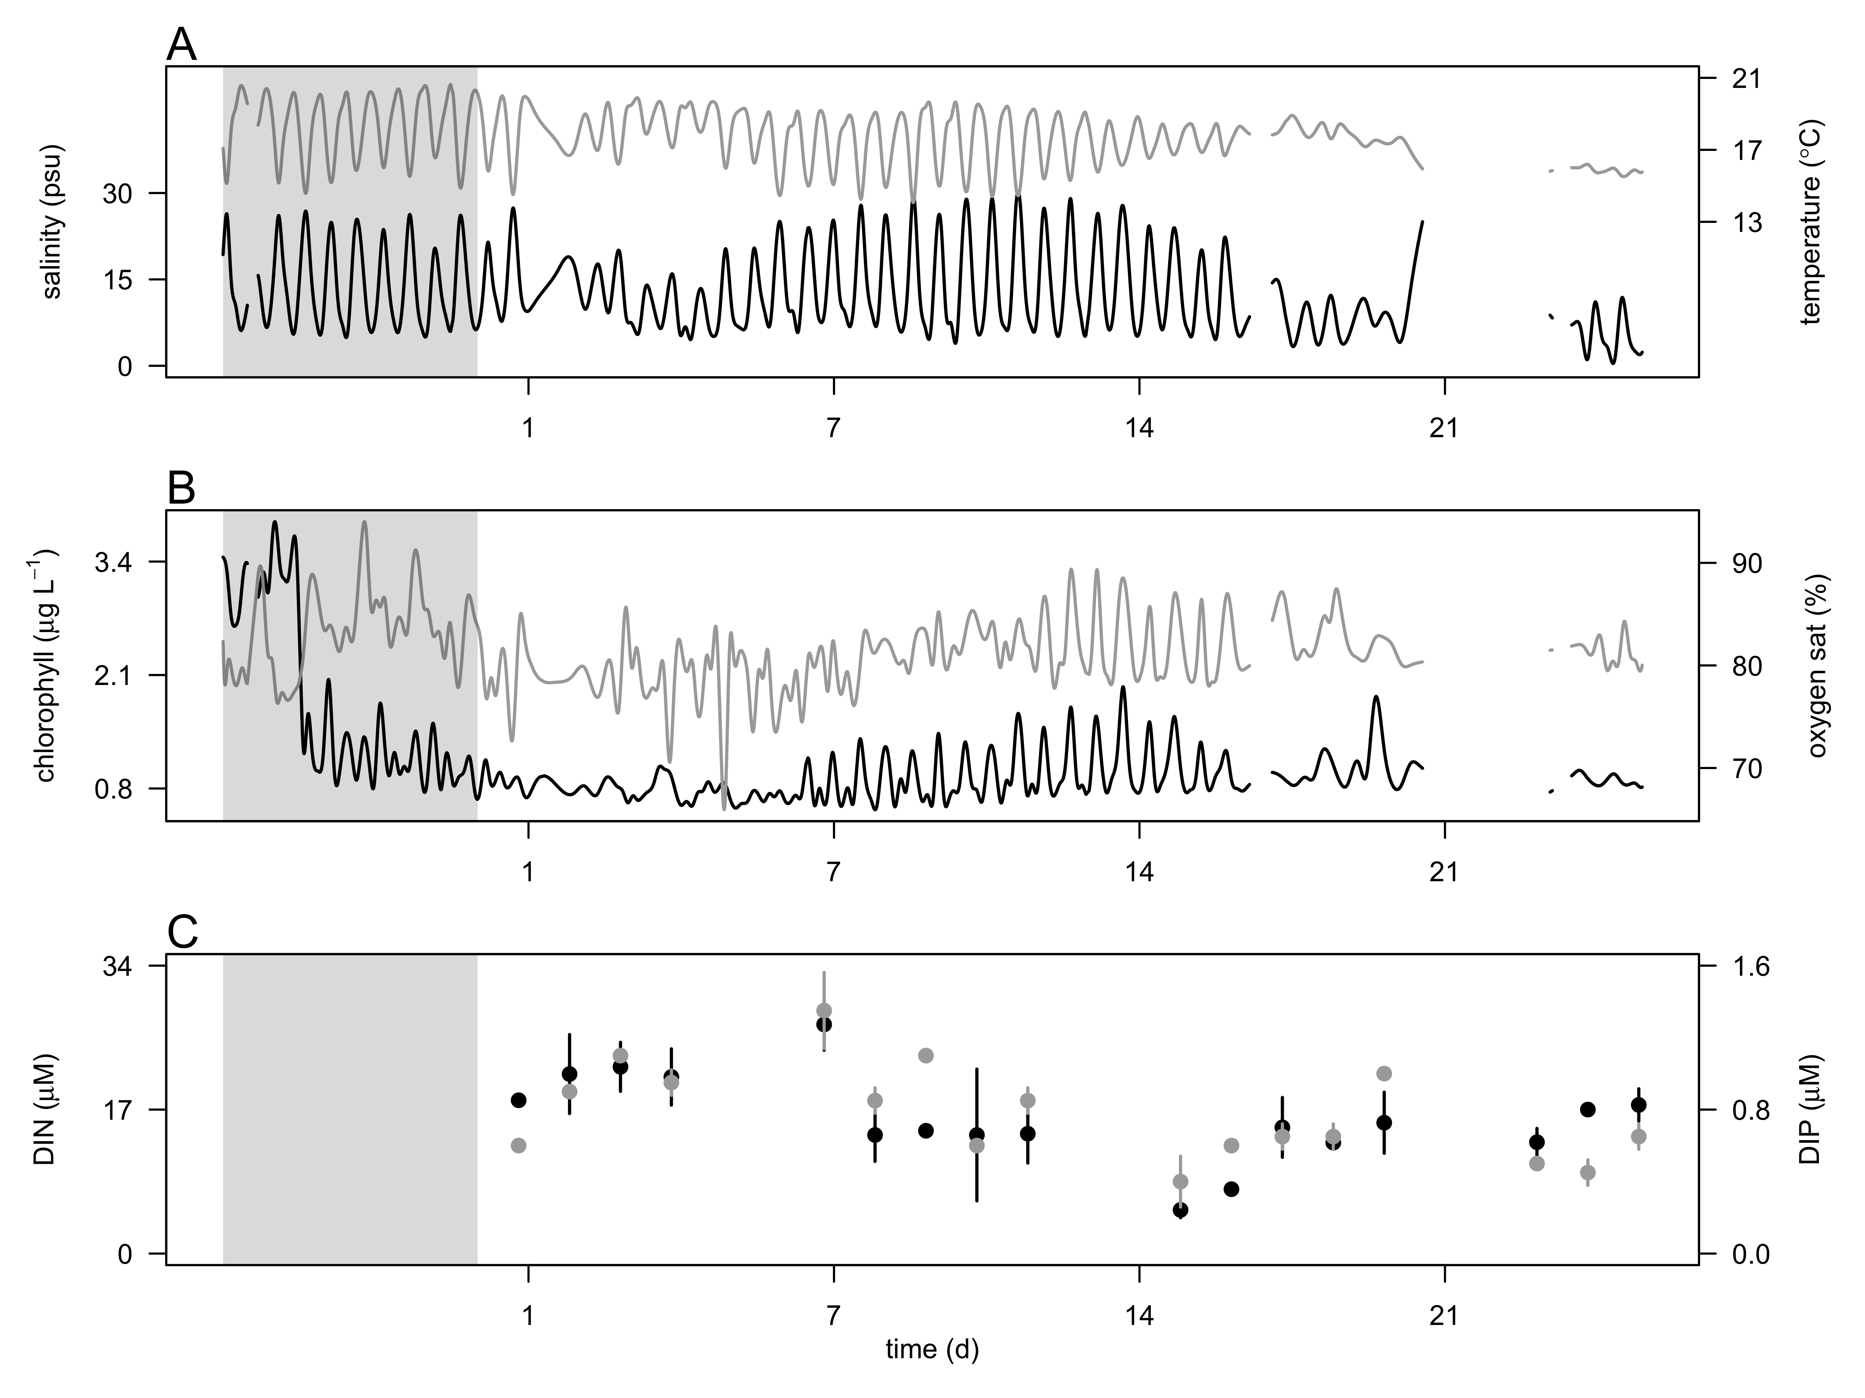

**Fig. 1** Hydrographic conditions prior and during the 4 week-survey in the CRE at 2.4 m depth. A) Salinity (psu, black line) and temperature (ºC, grey line). B) Chlorophyll *a* concentration (µg L-1, black line) and oxygen saturation (%, grey line), and C) concentrations of dissolved inorganic nitrogen (DIN, µM, open circle) and phosphorus (DIP, µM, black circle). Vertical bars represent the ranges of nutrient concentrations. The grey region represents the week prior the start of the survey.

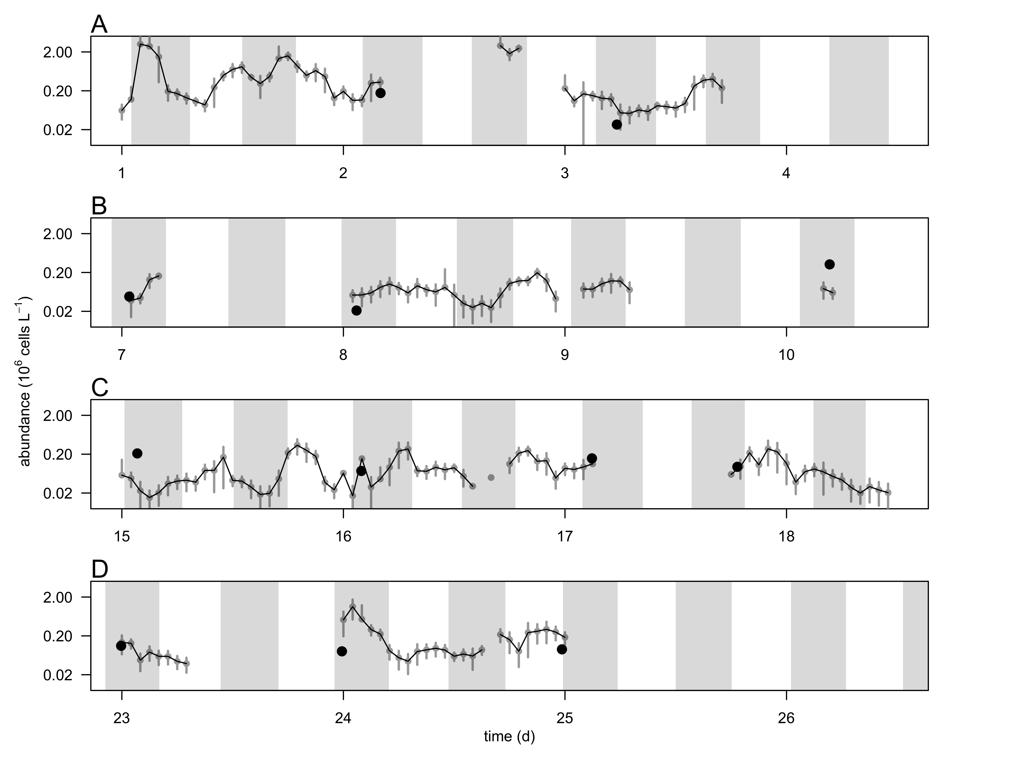

**Fig. 2** Hourly-averaged cell abundances of *Teleaulax*-like cryptophytes(grey circles and black line, 106 cells L-1) determined by continuous flow cytometry and abundance of *Mesodinium major* (black circles, 106 cells L-1) determined from discrete samples taken during the 4-week survey (A-D, week 1-4). Vertical bars represent the standard deviation of the hourly-mean cell abundance (n=20). Grey regions represent flood tide.

**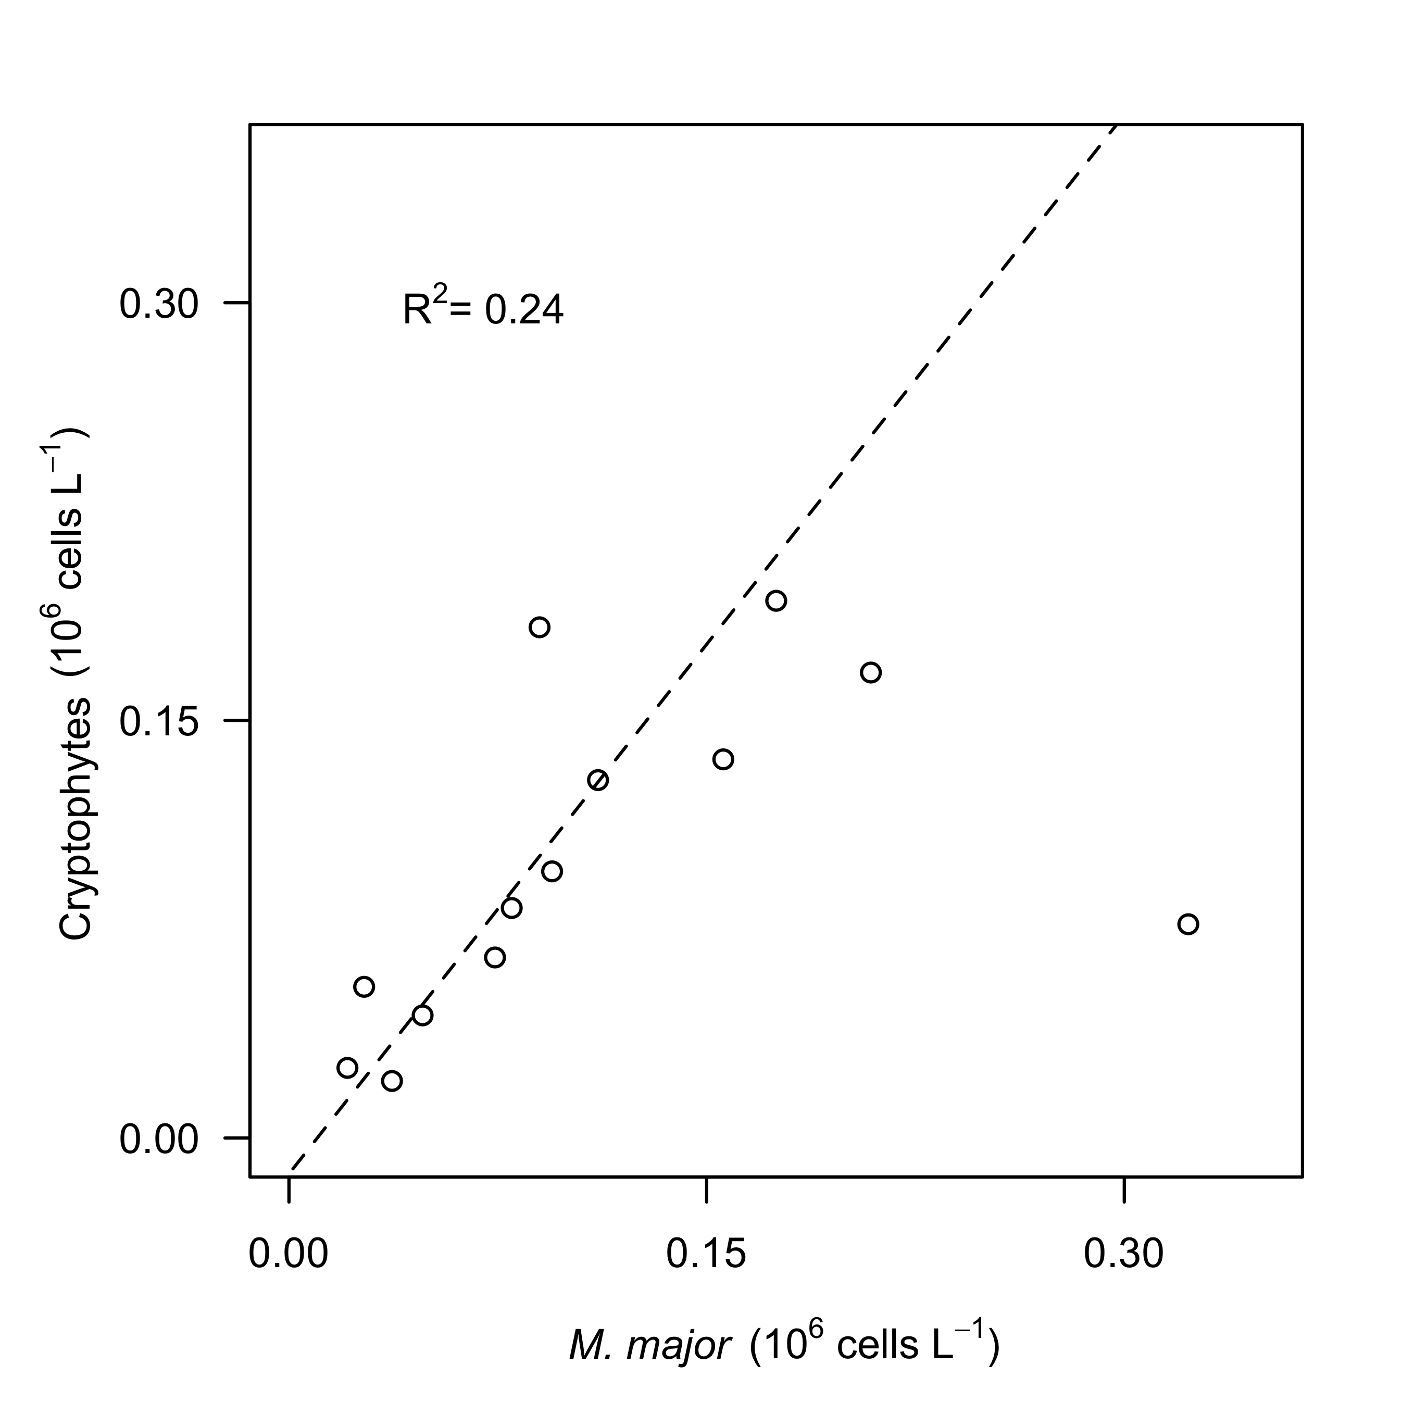**

**Fig. 3.** Relationship between hourly-average cell abundances of *Teleaulax*-like cryptophytes (106 cells L-1)and *Mesodinium major* (106 cells L-1) during the survey in the Columbia River estuary. Dashed lines represent model II linear regression of plotted data and R2 represents the coefficient of determination.

**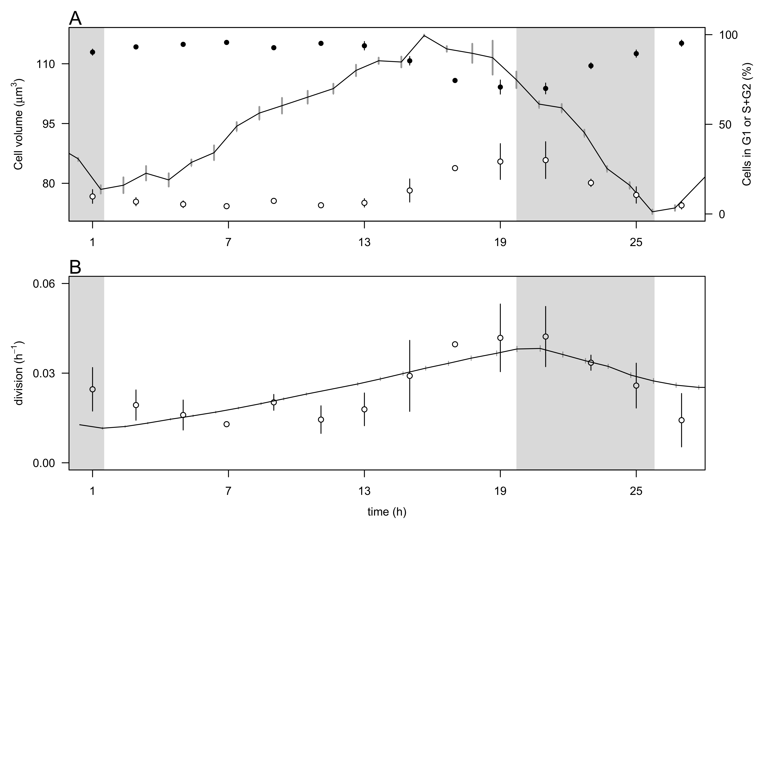**

**Fig. 4.** Comparison of the size-based and cell-cycle based estimates of division rates for a cultured cryptophyte isolate during a 28-hr experiment.A) Hourly- averaged cell volume of *Rhodomonas sp.* (µm3, black line) and percentage of cells in G1 (close circles), and S+G2 (open circles) phases. B) Hourly division rates (h-1) based on the size distribution (black line) and on cell cycle analyses (open circles). The grey regions indicate night. Vertical bars represent standard error (n=20 for cell volume, n=3 for the percent of cells in G1 and S+G2 phases, n=24 for the size-based division rates).

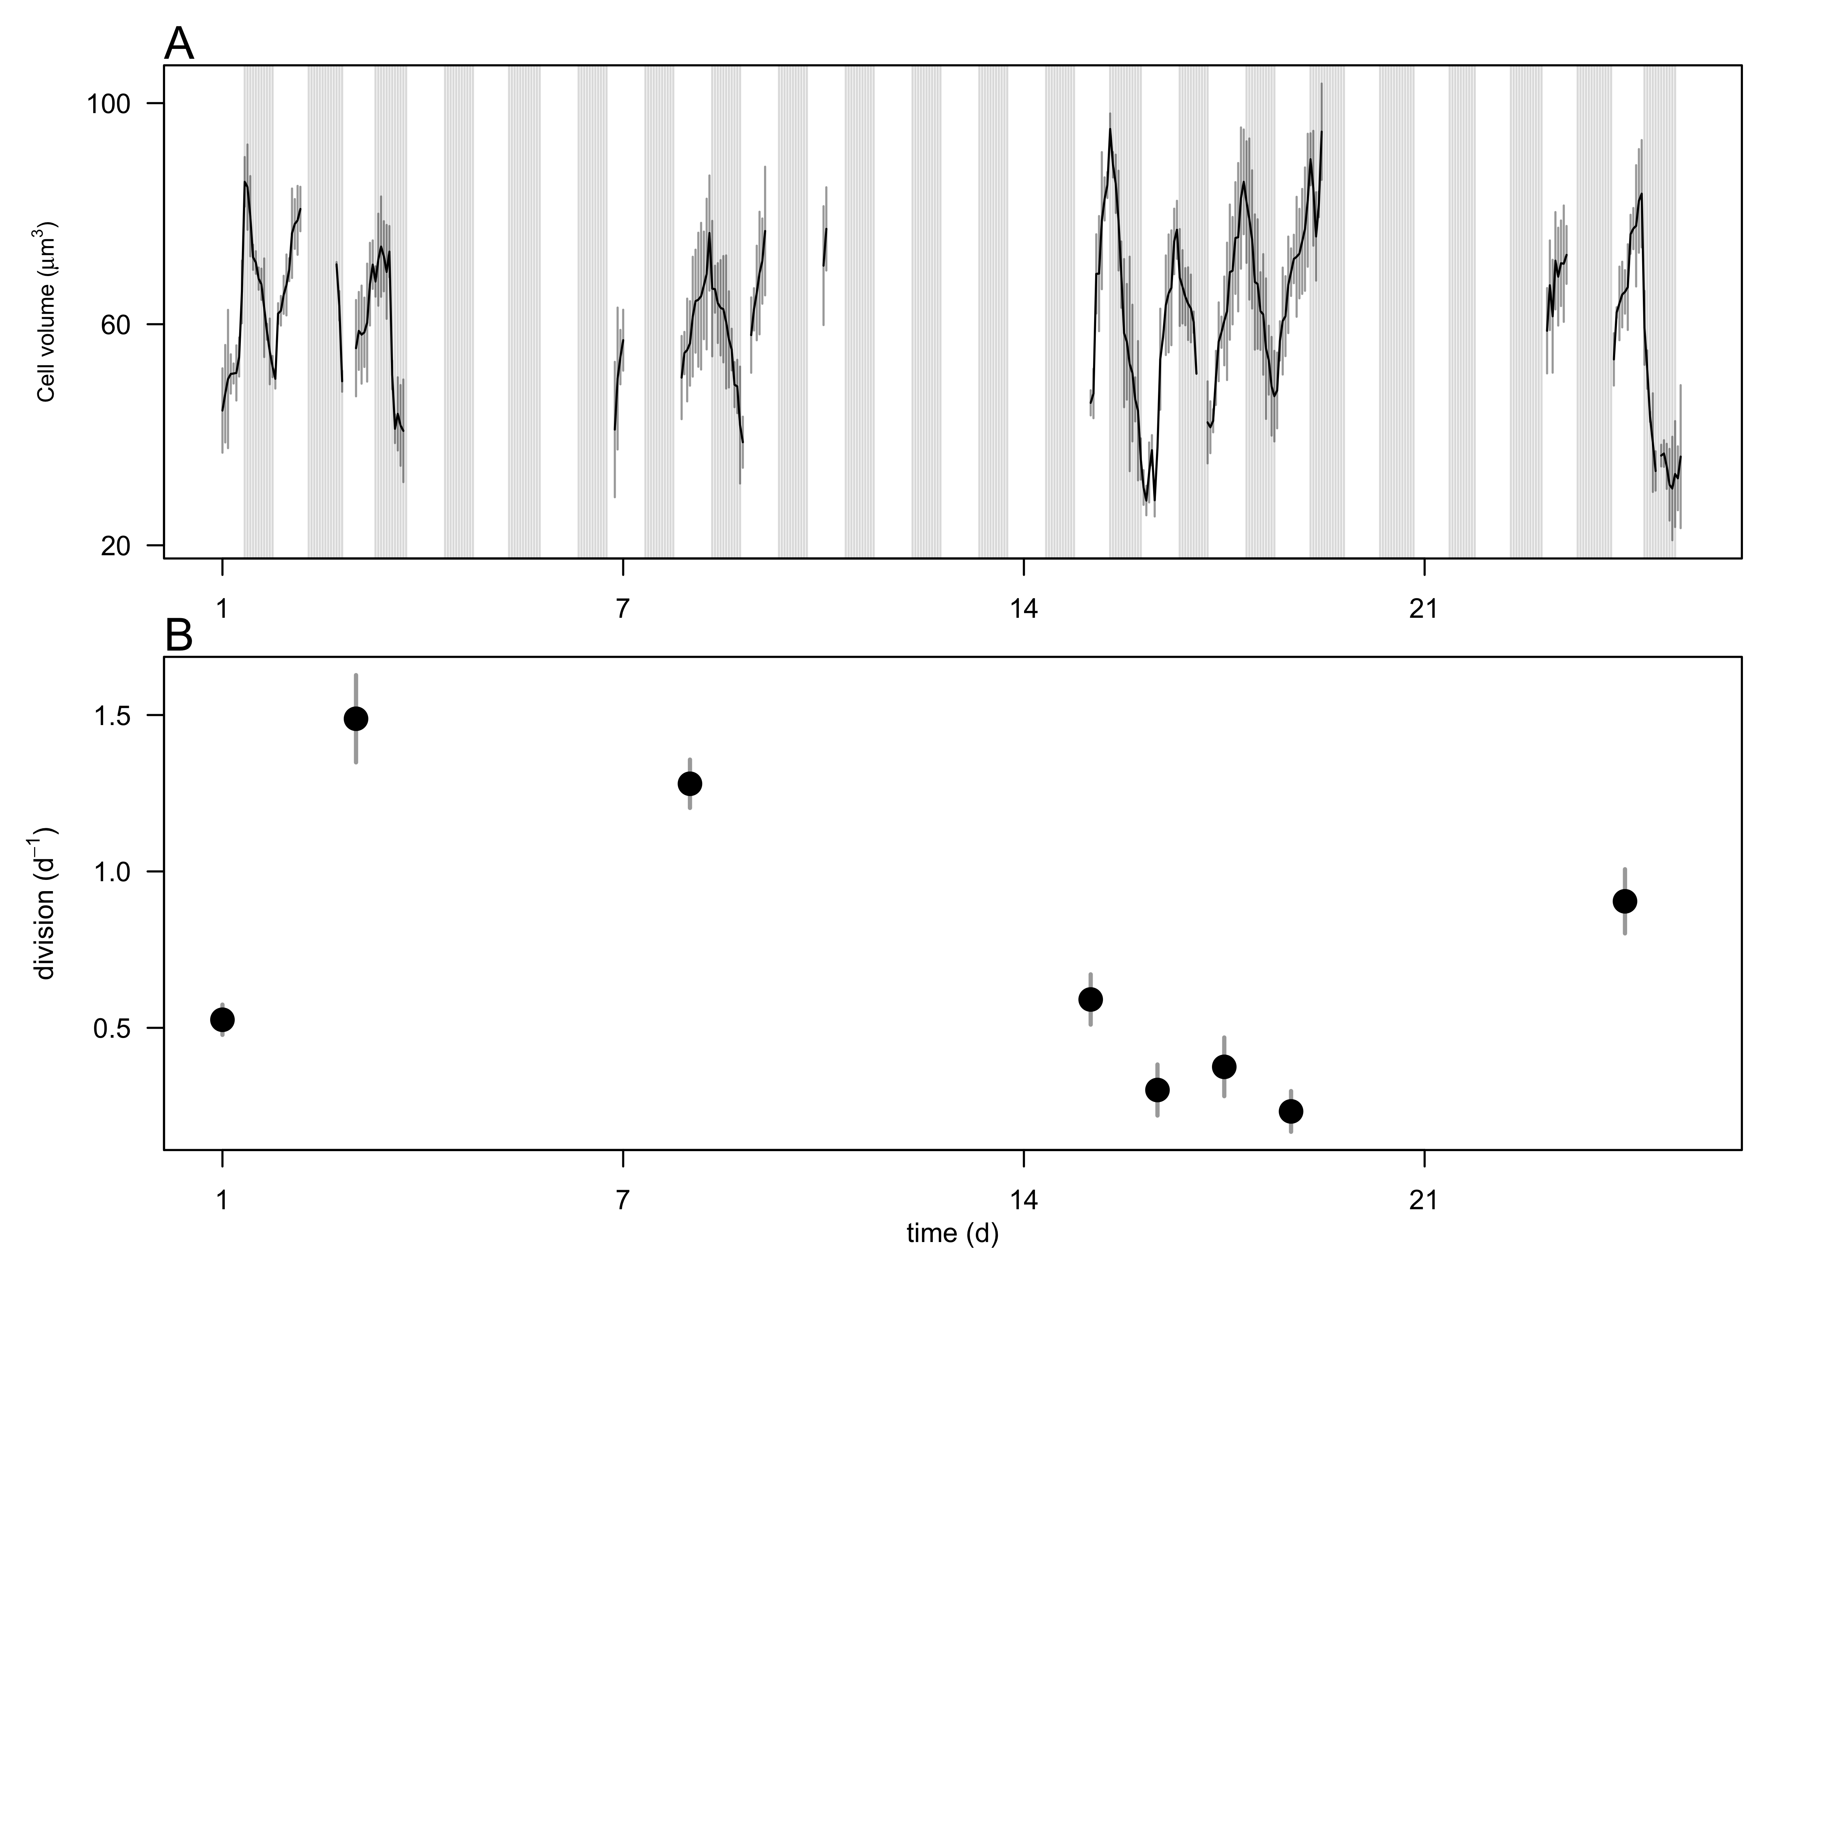

**Fig. 5.** A) Hourly-averaged cell volumes of *Teleaulax*-like cryptophytes (µm3) estimated by SeaFlow during the survey. Vertical grey bars represent the standard deviation of the hourly-mean cell volume. The grey regions indicate night. B) Daily rates of cell division (d-1) of *Teleaulax*-like cryptophytesduring the survey. Vertical bars represent the propagated standard error of the sum of hourly division rate estimates during each of the ten 24 h-period.

*The following supplement accompanies the article*

**Dynamics of *Teleaulax* cryptophyte prey during the decline of red water blooms**

**in the Columbia River Estuary**

Maria Hamilton, Gwenn M. Hennon, Joseph Needoba, Katie Maxey, Rhonda Morales, Tawnya Peterson, Megan Schatz, Jarred Swalwell, Peter Zuber, E. Virginia Armbrust, Francois Ribalet \*

\* Corresponding author: [ribalet@uw.edu](mailto:ribalet@uw.edu)

*Marine Ecology Progress Series XXX: XX–XX (201X)*

**Supplement.**

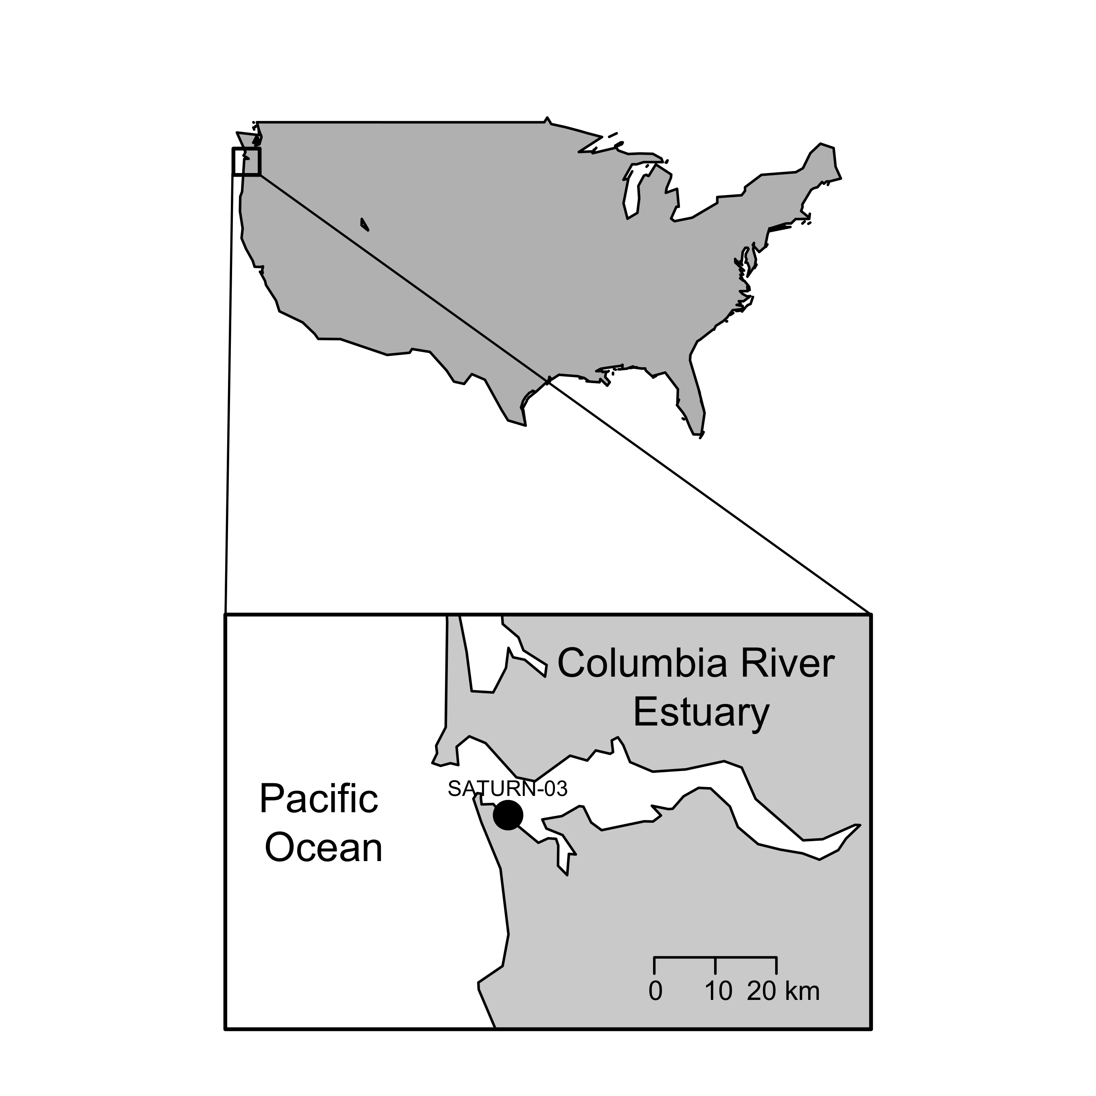

**Fig. S1** Map of the Columbia River Estuary with the station SATURN-03 location (black dot).

**Macintosh HD:Users:francois:Documents:DATA:SeaFlow:CMOP:CMOP_git:manuscript:manuscript_V3:FigureS3.pdf**

**Fig. S2.** Flow cytometric signatures and micrograph of glutaraldehyde-fixed *Teleaulax*-like cryptophytes. A) Red fluorescence (692 nm wavelength) from chlorophyll versus forward light scatter (related to cell size) shows phytoplankton community structure, cryptophyte population (red dots, see right panel) and detritus (low red fluorescence) (left panel). Red fluorescence (692 nm wavelength) versus orange fluorescence (527 nm wavelength) from phycoerythrin uniquely identified a population of cryptophyte (red dots), and a tight peak of uniform fluorescent microspheres (red circle) added as an internal standard (right panel). Cells with low orange fluorescence are the phytoplankton populations shown on the left panel. B) Micrographs using transmitted-light (A) and epifluorescence (B) microscopy after cell sorting by flow cytometry of the cryptophyte population (red dots shown in panels A). Scale bar is 5 µm.

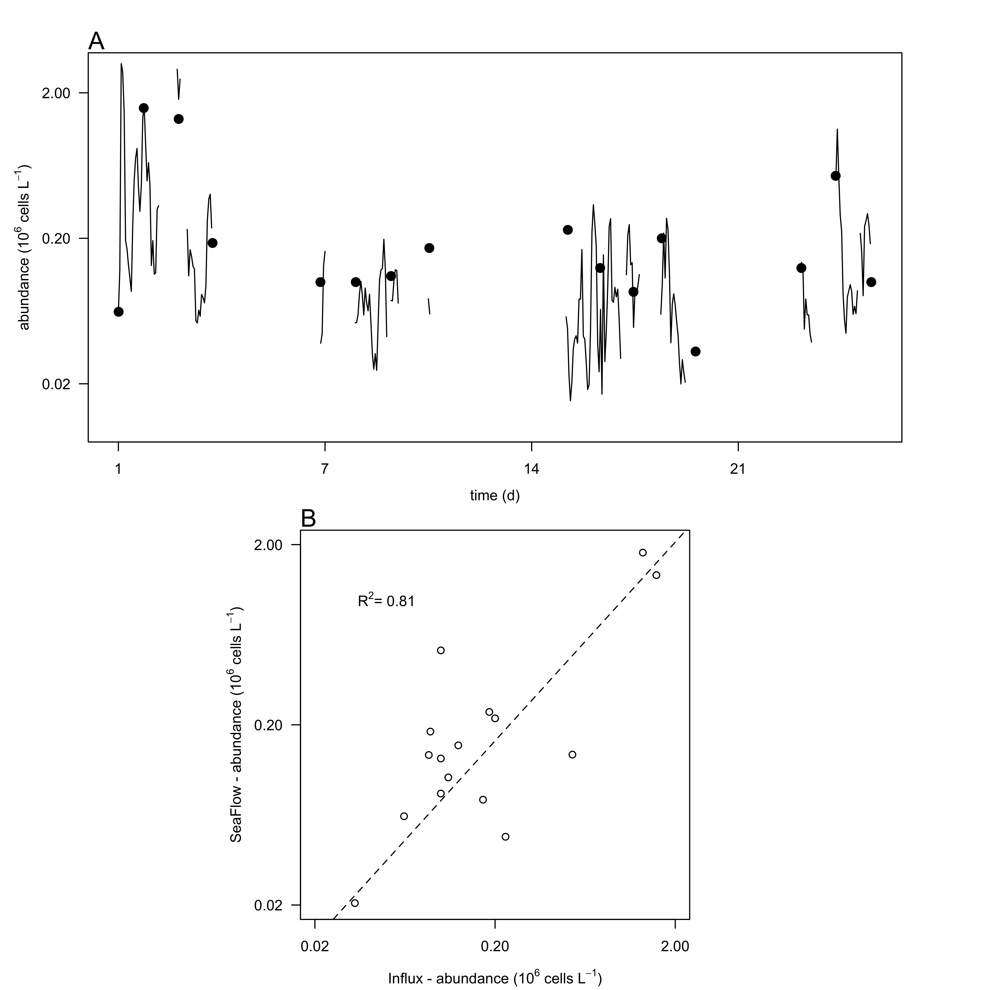

**Fig. S3.** Comparison of cell counts obtained with different methods. A) Cell abundances of *Teleaulax-*like cryptophytes (106 cells L-1) during the survey measured with the SeaFlow instrument (black line) and measured with a BD Influx cell sorter (red circles). B) Correlation of cell abundances measured by the two instruments. Dashed lines represent model II linear regression of plotted data and R2 represents the coefficient of determination.

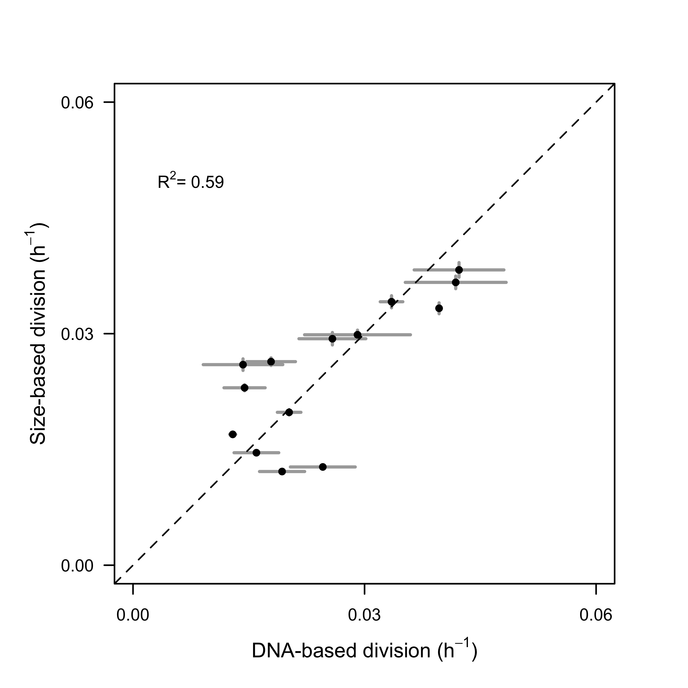

**Fig. S4.** Comparison of size-based division rate estimates (h-1) with DNA-based estimates of division rates (h-1) of *Rhodomonas* sp. in cultures over the 28-hr time course experiment. Dashed lines represent model II linear regression of plotted data and R2 represents the coefficient of determination.

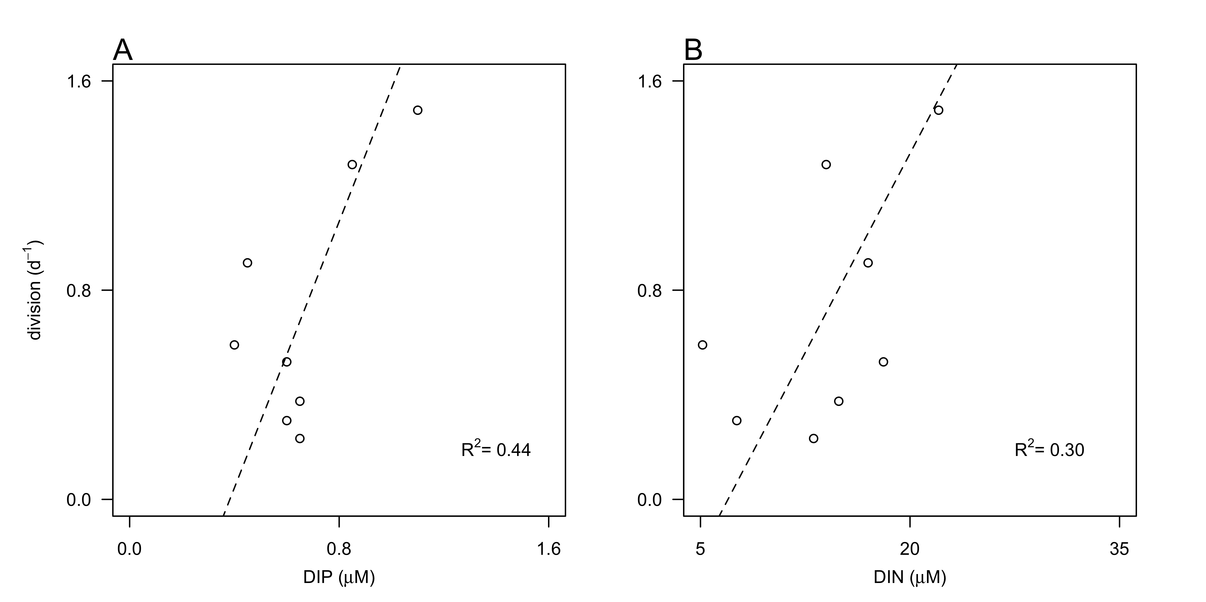

**Fig. S5.** Relationship between division rates (d-1) of *Teleaulax*-like cryptophytes with daily-averaged concentrations of A) dissolved inorganic (DIN, µM) and B) phosphate (DIP, µM) during the survey. Dashed lines represent model II linear regression of plotted data and R2 represents the coefficient of determination.